Optimizing Lactic Acid Recovery from Vinasse: Comparing Traditional and Intensified Process Configurations
Lucas de Oliveira Carneiro,ª Romildo Pereira Brito,ª Karoline Dantas Brito,ª
ªFederal University of Campina Grande, R. Aprígio Veloso 882, Campina Grande 58429-900, Brazil
karoline.dantas@ufcg.edu.br
Abstract
Biological processes are the major source of lactic acid, one of the chemical commodities of great interest to the industry, because of the optical purity obtained in such processes. One of these processes can be the ethanol fermentation, which produces a considerable amount of lactic acid as by-product. However, fermentation results in high diluted streams with a considerable amount of other organic acids and impurities that bring more complexity to the purification process. Therefore, the objective of the present work is to develop the optimal design of the lactic acid recovery process from vinasse using intensification technologies such as mechanic vapor recompression and reactive divided wall column (RDWC). Two configurations were evaluated for the process, one conventional with reactor and column distillation, and an intensified with a single RDWC. The Total Annual Cost (TAC) was optimized, and the results compared in the bases of operational, economic, and environmental indicators. The intensified configuration presents the lowest TAC, but the capital cost of this process is a little higher than conventional configuration. In the other side, the conventional configuration, even with the lowest CAPEX, present high operational costs, and carbon emissions, beside more methanol consumption and water use.
Keywords: Reactive Distillation, Process Intensification, Lactic Acid Recovery.
  - Introduction
Lactic acid (LAc) is one of the most important chemical commodities due to its large commercial application in the food and pharmaceutical industries. The LAc molecule has a chiral carbon that gives it optical activity, and, therefore, can be found in two optical isomers: D(-)-LAc and L(+)-LAc, the latter being the most desired in the industry as it does not pose risks to human health. The request for optical purity implies in the fact that, currently, 90% of the world's lactic acid production occurs via biotechnological routes.
The use of biotechnological routes, however, presents some disadvantages, such as high dilution, presence of other organic acids and impurities, and the strong interaction between lactic and water (GONZÁLEZ-NAVARRETE et al., 2022). Therefore, several purification methods have been investigated such as precipitation, extraction, adsorption, short-path evaporation, and membrane separation, but the most used in the literature is the reactive distillation (RD) technology. In this process, lactic acid reacts with an alcohol, especially methanol, to form an ester. As the ester formed has greater thermal stability than the lactic acid, it is recovered in a distillation column and is subsequently hydrolyzed to form lactic acid again in a reactive distillation column (PAZMIÑO-MAYORGA et al., 2021).
Given the importance of lactic acid to the industry and the need to reduce or reuse industrial waste, the objective of this work is to develop a process for recovering the lactic acid present in vinasse produced during ethanol fermentation. The main contributions of this work to the existing literature consist of considering multiple species in the feed stream, which directly impacts methanol consumption and energy supply, and evaluating the recovery of lactic acid at lower concentration levels, with 2% wt.
  - Process Design
The process to produce lactic acid from vinasse consists of three areas, as highlighted in Figure 1. The process flowsheet was modeled using Aspen Plus V12 software. UNIQUAC-HOC was the thermodynamic model used, which uses the UNIQUAC equation to predict the non-ideality of the liquid phase and the Hayden O'Connell equation of state to predict the dimerization of organic acids in the vapor phase.

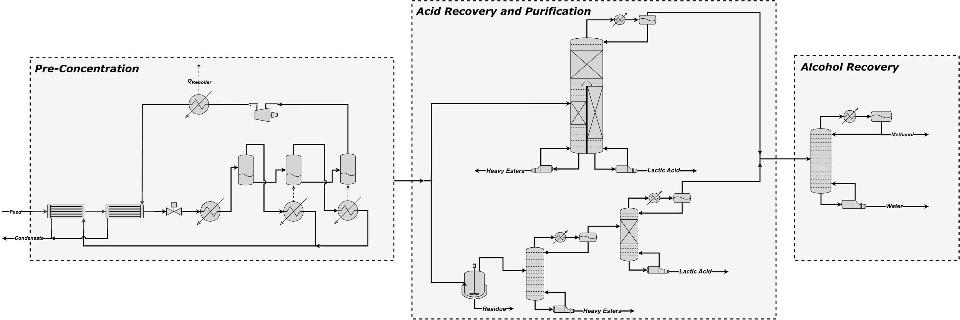
Figure 1. Process flowsheet to produce lactic acid from vinasse.
The first area of the process is pre-concentration, in which the vinasse feeds a triple-effect evaporation so that most of the water is removed. This removal is necessary because esterification reactions are limited by chemical equilibrium, even in the presence of catalysts (PÖPKEN et al., 2000), and the presence of water directs the reaction toward the reactants. In this paper, the vapor produced in the last stage of evaporation is used as a heating fluid at some points in the process after mechanical vapor recompression (MVR) (CARNEIRO et al., 2022).
After pre-concentration, the concentrated vinasse is sent to the acid recovery and purification area, where lactic acid (LAc) is esterified with methanol (MeOH), forming methyl lactate (MetLAc). Next, methyl lactate is separated from the remaining esters and organic acids and hydrolyzed into lactic acid.
To increase the esterification conversion, the Amberlyst 15 ion exchange was used as a catalyst (PÖPKEN et al., 2000; PAZMIÑO-MAYORGA et al., 2021). The reactions considered in the process modeling are shown below in Eq. (1) to Eq. (6).
$$C_{3}H_{6}O_{3} \left(LAc\right)+CH_{3}OH\left(MeOH\right)↔C_{4}H_{8}O_{3}\left(MetLAc\right)+H_{2}O$$ | (1)
$$C_{2}H_{4}O_{2} \left(HAc\right)+CH_{3}OH\left(MeOH\right)↔C_{3}H_{6}O_{2}\left(MetHAc\right)+H_{2}O$$ | (2)
$$C_{4}H_{6}O_{4} \left(SUc\right)+CH_{3}OH\left(MeOH\right)↔C_{5}H_{8}O_{4}\left(MMS\right)+H_{2}O$$ | (3)
$$C_{5}H_{8}O_{4} \left(MMS\right)+CH_{3}OH\left(MeOH\right)↔C_{6}H_{10}O_{4}\left(DMS\right)+H_{2}O$$ | (4)
$$2C_{3}H_{6}O_{3} \left(LAc\right)↔C_{6}H_{10}O_{5}\left(DLAc\right)+H_{2}O$$ | (5)
$$C_{3}H_{6}O_{3} \left(LAc\right)+C_{6}H_{10}O_{5}\left(DLAc\right)↔C_{9}H_{14}O_{7}\left(TLAc\right)+H_{2}O$$ | (6)
Two configurations were evaluated for the acid recovery and purification area. Figure 2 compares the two configurations.
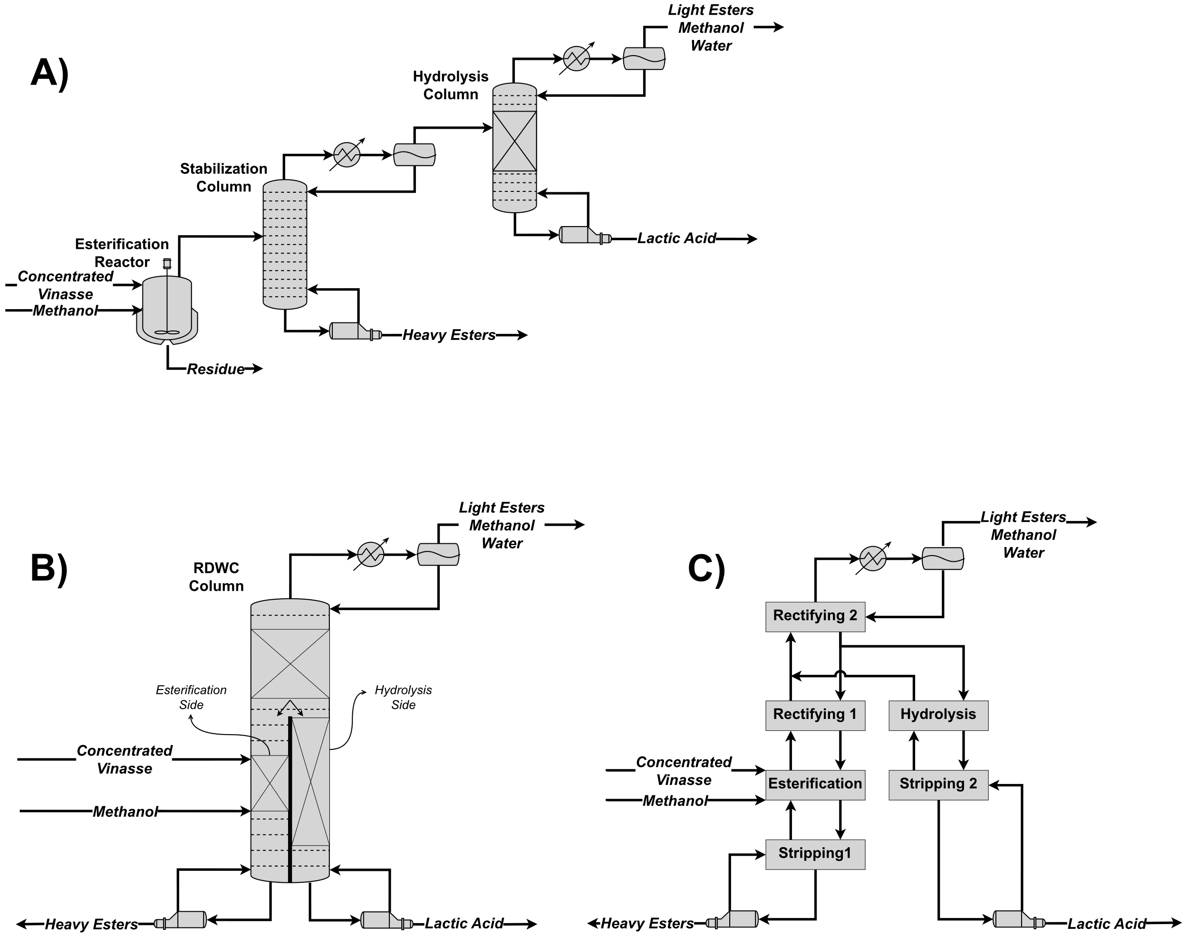
Figure 2. A) Flowsheet of the conventional configuration; B) Flowsheet of the intensified configuration (RDWC); and C) Sections and interconnections of the RDWC column.
The conventional configuration consists of 1) esterification reactor, which operates under conditions of temperature and pressure sufficient to vaporize the water and esters formed; 2) stabilization column, which aims to remove heavy esters and glycerol that were vaporized in the reactor; and 3) hydrolysis column, which have the objective to convert the methyl lactate formed in the reactor into lactic acid.
The intensified configuration consists of coupling the esterification reactor, the stabilization column, and the hydrolysis column in a single reactive divided-wall column (RDWC). The concentrated vinasse feeds the left side of the wall, where the esterification reactions occur. The vaporized esters, as well as the excess of methanol, and the water produced, rise to rectification section 1. The vapor leaving rectification section 1 contains light esters, water, and excess methanol. This vapor is directed to the rectification section 2, where all methanol, light esters produced, and excess water will be removed as top product. The liquid leaving the rectification section 2 - that consists of methyl lactate and water - is divided between the two sides of the RDWC. In the hydrolysis section – the right side of the wall - methyl lactate is converted into lactic acid; the vapor stream from this section goes directly to the rectification section 2, while the liquid stream goes to the stripping section 2, where the lactic acid is obtained as a bottom product.
The last area of the process is the alcohol recovery area, which have the function to separate the methanol from water and any residues of methyl lactate.
  - Process Optimization
The objective function used to determine the optimal process configuration was the Total Annual Cost (TAC), calculated using Eq. (7). In the equation, OPC represents the operational cost of the process (US$/Year) and CAPC represents the capital cost (US$). The payback considered was 5 years. All equations used to calculate the capital and operational costs were implemented in Aspen Plus through the “Calculator” block using Fortran language. TAC optimization was performed through an iterative sequential procedure.
$$TAC=OPC+\frac{CAPC}{Payback}$$ | (7)
  - Results and Discussion
Table 1 presents the optimal results of the conventional and intensified configurations, obtained after optimization. The lower energy consumption in the preconcentration area of the intensified configuration is related to the lower energy consumption in the acid recovery and purification area. As previously mentioned, compressed steam is primarily used to supply energy for the hydrolysis column’s reboiler. As this consumption is lower in the intensified configuration, the compressed vapor has a higher enthalpy after passing through the reboiler and can provide more energy to preheat the vinasse, reducing the supply of live steam in the first stage of evaporation.
The alcohol recovery area showed similar results in both configurations. The result that deserves to be highlighted is the methanol make-up. It is observed that in the intensified configuration, make-up is reduced by approximately 44 % compared to the conventional configuration. This occurs, firstly, because the presence of the reactor results in methanol losses in the residue’s stream. Secondly, the loss of other esters in the global streams is smaller in the intensified configuration, especially of dimethyl succinate (DMS). DMS losses in the conventional configuration are 2.54 kmol/h, while in the intensified configuration these losses are equal to 0.09 kmol/h. Considering that, for each kmol of DMS formed, 2 kmol of methanol is consumed, the formation and loss of this ester ultimately represents a loss of methanol.
The amount of cooling water decreased significantly in the intensified configuration, going from 2,524.5 m³/h to 2,201.1 m³/h. This result improves the environmental indicators of the process, considering that the reduction in water consumption is being sought after by industries around the world.
When analyzing Table 1, it is possible to observe that the intensified configuration presented a reduction of 9.5 % in the total operational cost when compared to conventional configuration. This result highlights how the use of intensification techniques is advantageous for separation processes, especially distillation. However, it is important to highlight that this result would be even better if the steam used in all reboilers in the distillation columns were of the same pressure.
The capital cost, however, negatively impacts the TAC of the intensified configuration, as it presents an increase of 3.32 % in relation to the conventional configuration. The main equipment that contributes to a higher capital cost are the vinasse preheaters, the compressor and the RDWC.
Table 1. Optimal results for the conventional and intensified configurations.
 | Conventional | Intensified
Pre-Concentration Area
Heat Duty (MW) | 11.33 | 9.02
Compressor Horsepower (MW) | 6.07 | 6.34
Capital Cost (MMU$) | 10.19 | 10.40
Operational Cost (MMU$/Y) | 5.49 | 5.11
Acid Recovery and Purification Area
Heat Duty (MW) | 14.09 | 12.27
Condenser Duty (MW) | -10.55 | -8.57
Capital Cost (MMU$) | 1.87 | 2.11
Operational Cost (MMU$/Y) | 1.28 | 1.50
Alcohol Recovery Area
Heat Duty (MW) | 0.69 | 0.70
Cooling Duty (MW) | -4.04 | -4.15
Methanol Make-Up (t/h) | 0.32 | 0.18
Capital Cost (MMU$) | 0.56 | 0.53
Operational Cost (MMU$/Y) | 1.64 | 1.01
Heat Duty (MW) | 16.34 | 14.26
Cooling Duty (MW) | -14.59 | -12.72
Electricity (MW) | 6.07 | 6.34
Operational Cost (MMU$/Y) | 8.42 | 7.62
Capital Cost (MMU$) | 12.62 | 13.04
Total Annual Cost (MMU$/Y) | 10.94 | 10.27
Total Carbon Emissions (kt/Y) | 47.78 | 44.61
A parameter that can define the choice for one or another configuration is the payback. In the calculations of the economic analysis, a period of 5 years was considered for the payback; however, if this time is extended to 10 years, the TAC of the intensified configuration will be even more attractive (8.92 MMU$/year) than that of the conventional configuration (9.68 MMU$/year). Therefore, higher paybacks favor the implementation of the intensified configuration.
When the environmental results are observed, it is possible to conclude that, even requiring more high-pressure steam, the intensified configuration reduces CO₂ emissions by 6.63 % when compared to the conventional configuration. This result is mainly a function of the lower low-pressure steam consumption in the hydrolysis reboiler of the intensified configuration. Figure 3 and Figure 4 show the optimal flowcharts obtained.
  - Conclusions
This work evaluated two process configurations for the recovery of lactic acid present in vinasse. The process flowsheets were simulated and optimized in the Aspen Plus. With the optimized results, it was possible to observe that the use of a reactive divided-wall column (RDWC) showed improvements in the main operational indicators, specific consumption and operational cost, and environmental indicators (CO₂ emissions). The intensification configuration with RDWC presented a reduction in the TAC of the process, but its capital cost is higher than the conventional configuration. However, in higher payback periods, the advantage of RDWC over the conventional configuration becomes even more significant. Finally, proposals for process intensification are very attractive, primarily in a scenario of search for more sustainable processes.
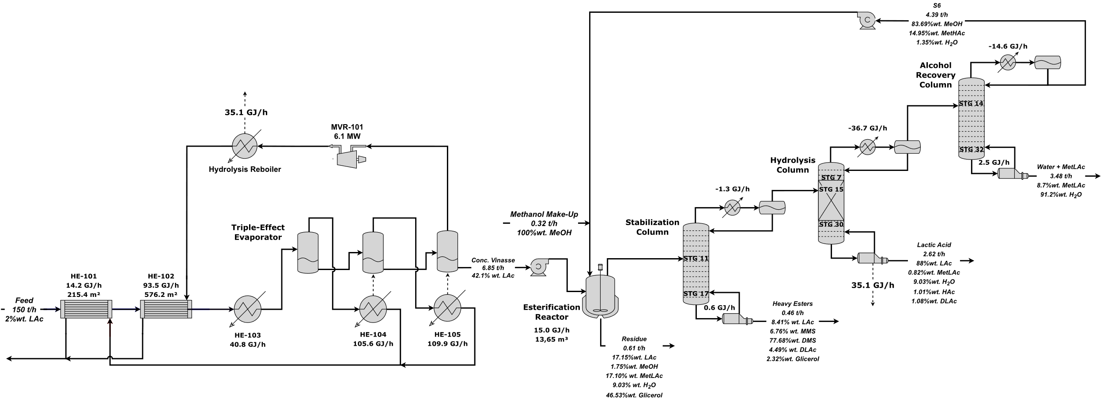
Figure 3. Optimal results for conventional configuration.
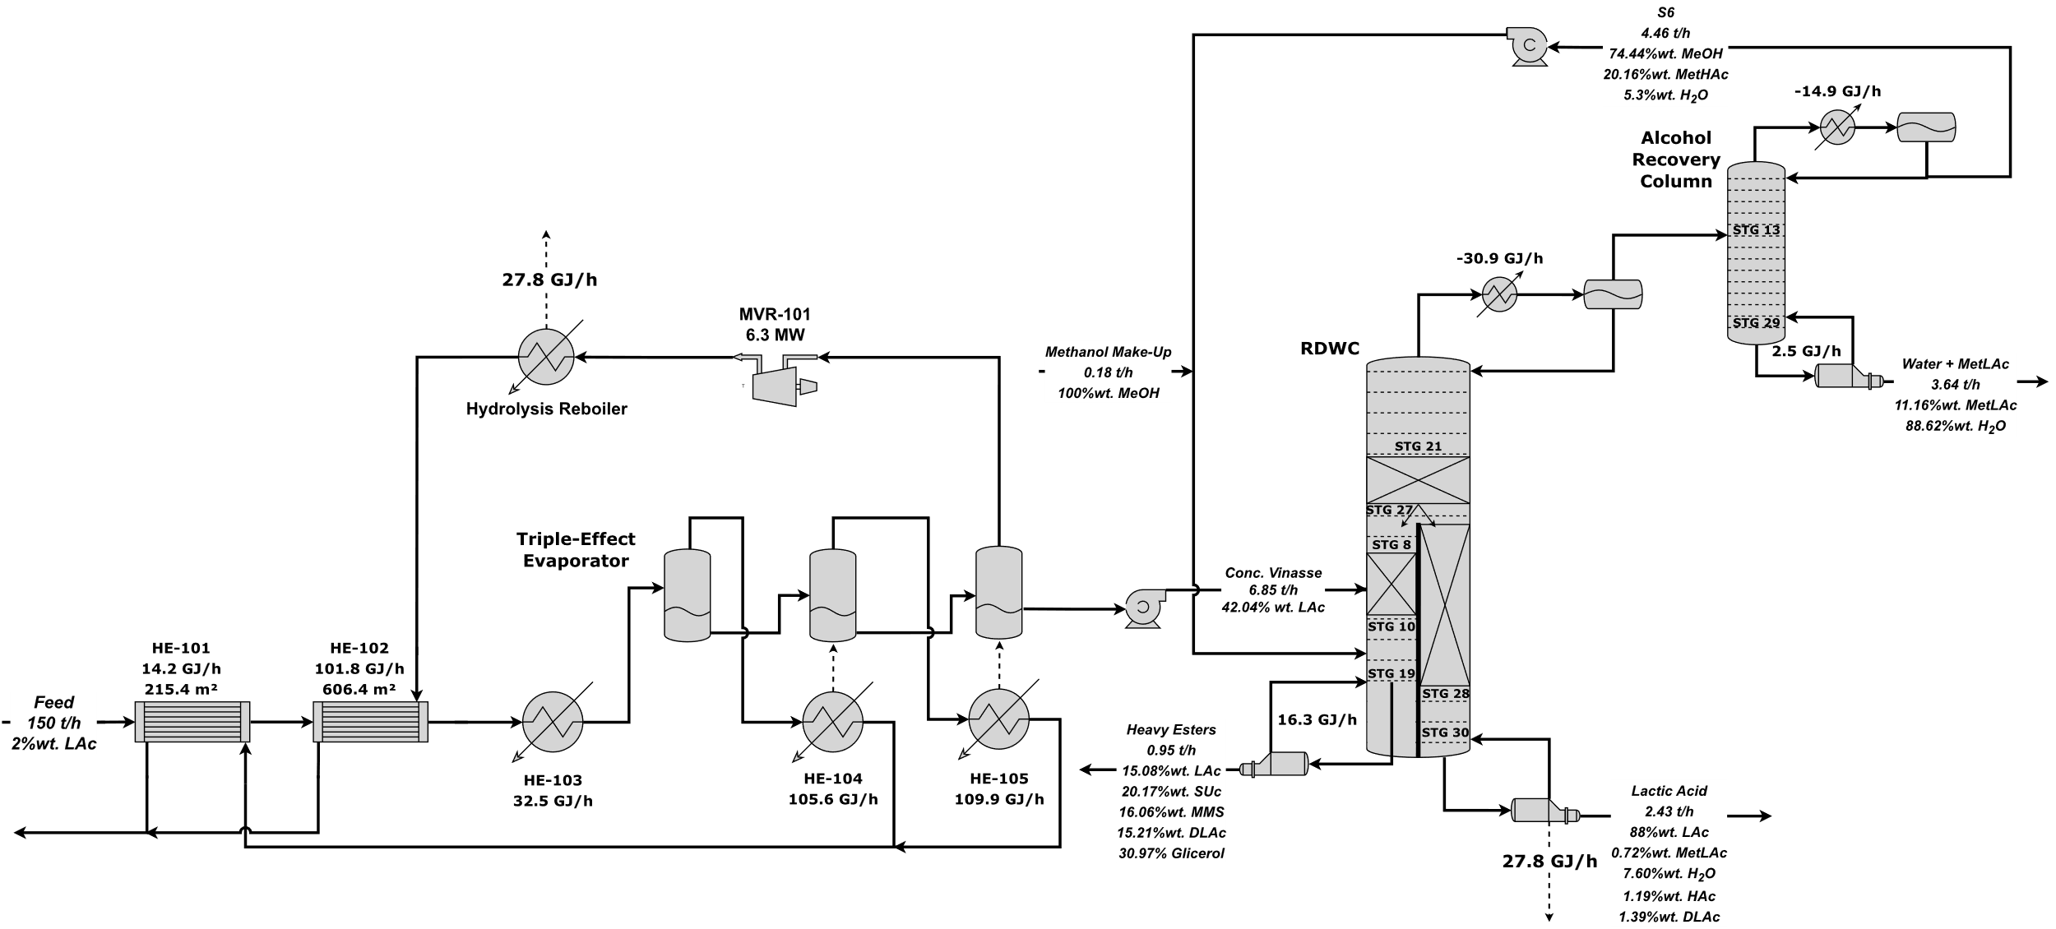
Figure 4. Optimal results for intensified configuration.
  - References
L. D. O. CARNEIRO, R. P. S. MATOS, W. B. RAMOS, R. P. BRITO, K. D. BRITO, 2022, Sustainable design and optimization of the recovery process of acetic acid from vinasse: Operational, economic, and environmental analysis, Chemical Engineering and Processing - Process Intensification, v. 181, p. 109176.
C. GONZÁLEZ-NAVARRETE, E. SÁNCHEZ-RAMÍREZ, C. RAMÍREZ-MÁRQUES, S. HERNÁNDEZ, E. COSSÍO-VARGAS, J. G. SEGOVIA-HERNÁNDEZ, 2022, Innovative Reactive Distillation Process for the Sustainable Purification of Lactic Acid, Industrial & Engineering Chemistry Research, v. 61, p. 621-637.
I. PAZMIÑO-MAYORGA, M. JOBSON, A. A. KISS, 2021, Conceptual design of a dual reactive dividing wall column for downstream processing of lactic acid, Chemical Engineering and Processing - Process Intensification, v. 164, p. 108402.
T. PÖPKEN, L. GÖTZE, J. GMEHLING, 2000, Reaction Kinetics and Chemical Equilibrium of Homogeneously and Heterogeneously Catalyzed Acetic Acid Esterification with Methanol and Methyl Acetate Hydrolysis, Industrial & Engineering Chemistry Research, v. 39, p. 2601-2611.

